Lab Exercise 13- Managing Namespaces in Kubernetes

Step 1: Understand Namespaces

Namespaces provide a mechanism for scoping resources in a cluster. Namespaces can be used to:

- Create environments for different applications or teams.
- Apply policies like resource quotas or network policies on a per-namespace basis.
- Separate operational environments (like development and production).

Step 2: List Existing Namespaces

To list all the namespaces in your Kubernetes cluster:

kubectl get namespaces
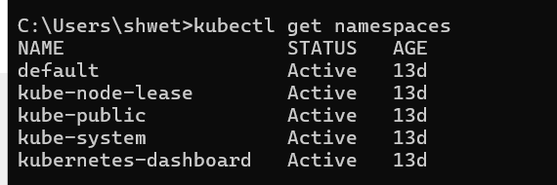

You will typically see default namespaces like default, kube-system, and kube-public.

Step 3: Create a Namespace

You can create a namespace using a YAML file or directly with the kubectl command.
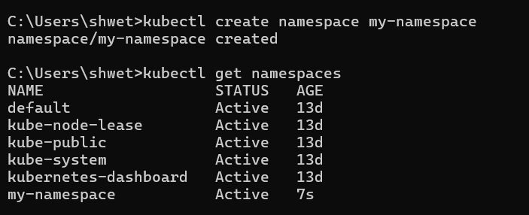

Using YAML File
Create a file named my-namespace.yaml with the following content:

apiVersion: v1
kind: Namespace
metadata:
name: my-namespace
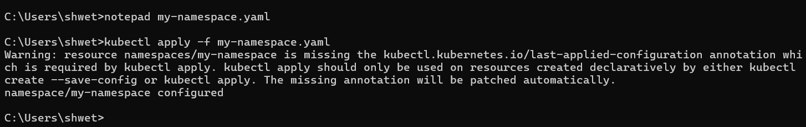

Apply this YAML to create the namespace:

kubectl apply -f my-namespace.yaml


Using kubectl Command

Alternatively, create a namespace using the kubectl command:

kubectl create namespace my-namespace

Verify that the namespace is created:

kubectl get namespaces


You should see my-namespace listed in the output.

Step 4: Deploy Resources in a Namespace

Create resources such as Pods, Services, or Deployments within the new namespace.

Deploy a Pod in the Namespace

Create a YAML file named nginx-pod.yaml with the following content:

apiVersion: v1
kind: Pod
metadata:
name: nginx-pod
namespace: my-namespace
spec:
containers:
- name: nginx
image: nginx:latest
ports:
- containerPort: 80

Apply this YAML to create the Pod:

kubectl apply -f nginx-pod.yaml
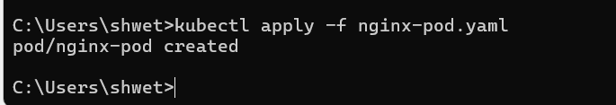

Check the status of the Pod within the namespace:

kubectl get pods -n my-namespace
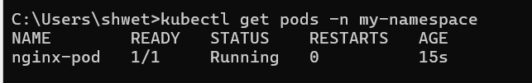

To describe the Pod and see detailed information:

kubectl describe pod nginx-pod -n my-namespace
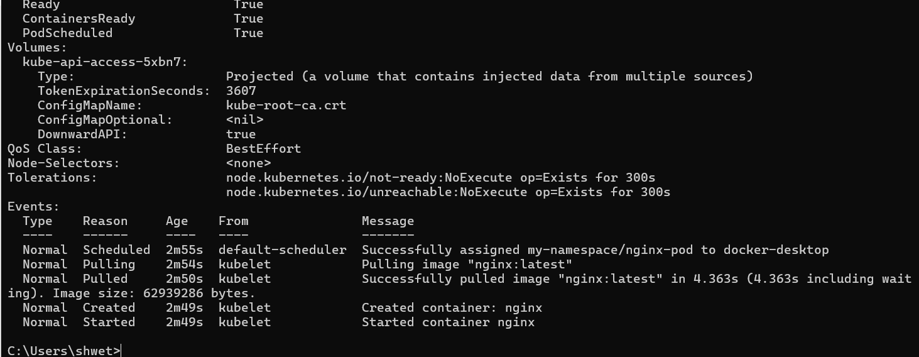

Create a Service in the Namespace

Create a YAML file named nginx-service.yaml with the following content:

apiVersion: v1
kind: Service
metadata:
name: nginx-service
namespace: my-namespace
spec:
selector:
app: nginx-pod
ports:
- protocol: TCP
port: 80
targetPort: 80
type: ClusterIP

Apply this YAML to create the Service:

kubectl apply -f nginx-service.yaml
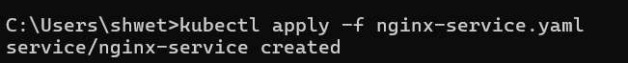

Check the status of the Service within the namespace:

kubectl get services -n my-namespace
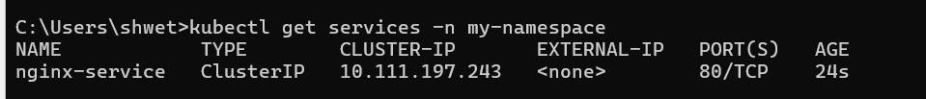

To describe the Service and see detailed information:
kubectl describe service nginx-service -n my-namespace
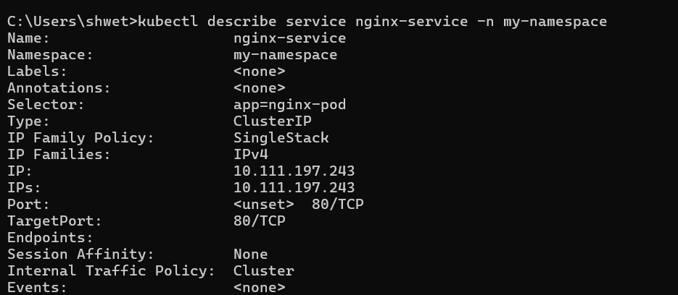

Step 5: Switching Context Between Namespaces

When working with multiple namespaces, you can specify the namespace in kubectl commands or switch the default context.

Specify Namespace in Commands
You can specify the namespace directly in kubectl commands using the -n or --namespace flag:

kubectl get pods -n my-namespace
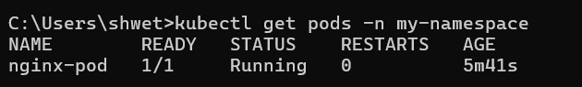

Set Default Namespace for kubectl Commands

To avoid specifying the namespace every time, you can set the default namespace for the current context:
kubectl config set-context --current --namespace=my-namespace

Verify the current context’s namespace:
kubectl config view --minify | grep namespace
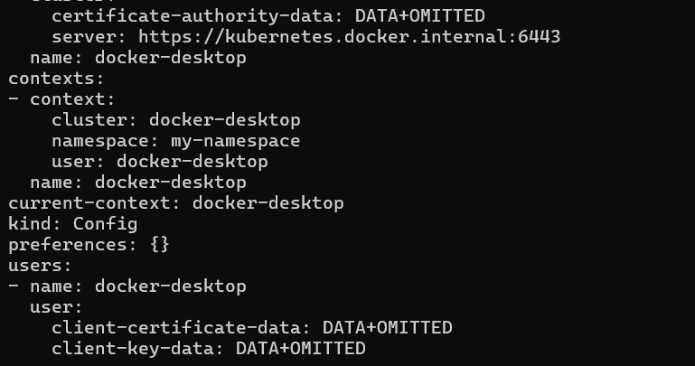

Step 6: Clean Up Resources

To delete the resources and the namespace you created:
kubectl delete -f nginx-pod.yaml
kubectl delete -f nginx-service.yaml
kubectl delete namespace my-namespace
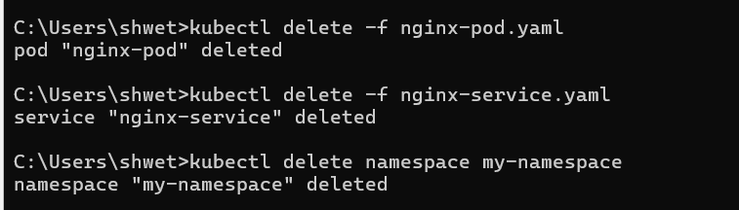
Ensure that the namespace and all its resources are deleted:

kubectl get namespaces
